Using COUNTIFS in Excel to find values greater than a specified criteria

COUNTIFS is a function commonly used in spreadsheet programs, such as Microsoft Excel or Google Sheets, to count the number of cells that meet multiple specified criteria. It allows you to apply multiple conditions to a range of cells and counts only the cells that satisfy all the given conditions. We use the COUNTIFS function with the "greater than" criterion (>) when we want to count the number of cells that meet a specific condition of being greater than a certain value.

We have a dataset that includes information about people performing online tasks on various dates, along with the time it took them to complete each task in minutes. The dataset includes instances where individuals have completed tasks on multiple dates, and some of those tasks took longer than 60 minutes. We want to determine the number of tasks completed by each person that exceeded 60 minutes.

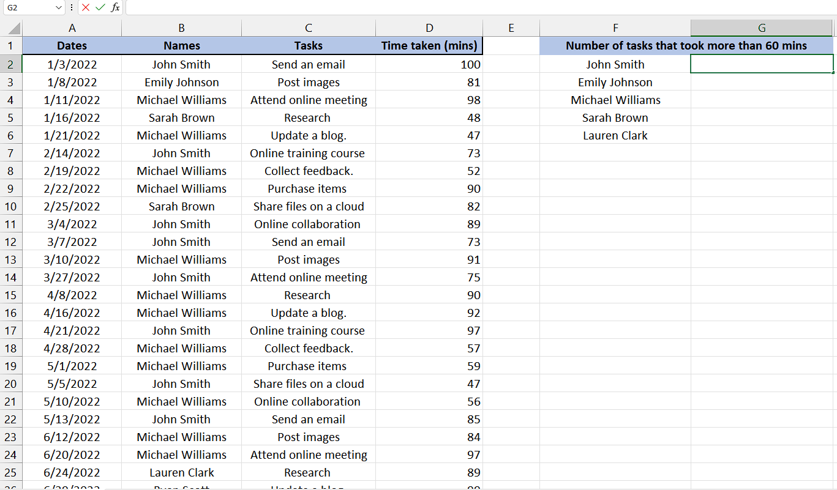

Follow the simple steps given below to learn how to use COUNTIFS Function:

Understanding the formula

The general syntax of the COUNTIFS function is as follows:

**COUNTIFS(range1, criteria1, [range2, criteria2], ...)**

* **range1** is the first range of cells that you want to evaluate.
* **criteria1** is the condition or criteria that you want to apply to range1.
* **[range2, criteria2] (optional)** represents additional ranges and criteria you can specify. You can have multiple pairs of range and criteria.
* **... (ellipsis)** indicates that you can continue adding more range-criteria pairs if needed.

Step 1 – Selecting the cell

* First of all, select any vacant cell in which you want use the formula to be implemented and get the results there.
* This is the cell where we will apply COUNTIF function with greater than criteria.



## Step 2 – Writing the formula

* After selecting the cell, press the **= button** on your keyboard.
* Then, Write COUNTIFS and select the **COUNTIFS Function** by pressing tab button on your keyboard.
* Once you’ve done that, then select the range of cells in which you want to count the number of the repeated text, value or number. For example, in this case it is **B2:B41** which **contains repeated names of people**.
* Then, **press comma (,) button** on your keyboard and you will move to next parameter which is **criteria1**.
* In this **parameter** of **criteria 1**, you’re going to **put a condition** to first range of cells that **what to count in the range1.** For instance, it is **cell** **F2** in this case which is name of the person we want to count that is repeated in range1.
* Then, **press comma (,) button** on your keyboard and you will move to next parameter which is **range2**.
* The **range2** is the range in which we will use the **cells on which** we want to apply the **criteria of greater than** certain value. For example, in our case, it is **D2:D41** which contains the **time taken by people to complete** their tasks and we want to use this range of cells for applying criteria of being greater than 60 minutes.
* Then, **press comma (,) button** on your keyboard and you will move to next parameter which is **criteria2.**
* The **criteria2** tells us the condition that we want to apply on the second range and in our case, we are using the **criteria of being greater than** a certain value which is **60 minutes for instance.** So, we will write **">60"** (quotes included) in this parameter.
* In the end, your formula would look like this,

**=COUNTIFS(B2:B41,F2,D2:D41,">60"**



## Step 3 – Implementing the formula

* Once you’ve written the formula, add the **closing parenthesis.**
* Then, **press Enter** to get the results.
* The **result of the formula is 7**, indicating that the **person mentioned in cell F2** has **completed 7 tasks** that took **more than 60 minutes.**



## Step 4 – Applying the formula to the whole range

* For applying the formula on the whole range, select the cell in which result is present. For example, it is **G2 cell** in our case.
* Then move your cursor on the **right bottom corner of the cell,** and your cursor would turn into **+ shape** which is called the fill handle.
* **Double-Click** on this **fill handle** and the formula would be applied to the whole range.

